# INDRODUCTION :

# overview

## I Design a business card using in this canva .

## That was very easy to use . Anyone to use this canva easier

# Purpose

## My project is creating a business card .

## I Create a business card using in this canva

# 2. Problems Definition&Design Thinking

## 2.1 Empathy map Screenshot 2023-10-12 221713.png

# 2.2 Brain strom and idea prioritization Screenshot 2023-10-12 221201.png

# 3. Result

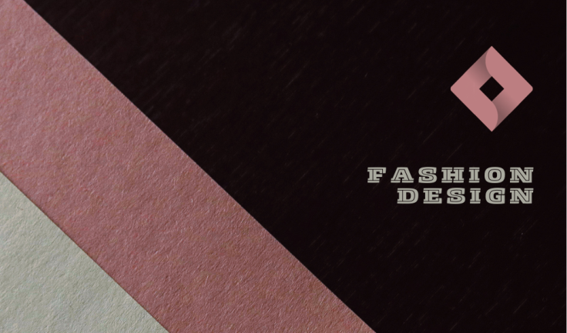 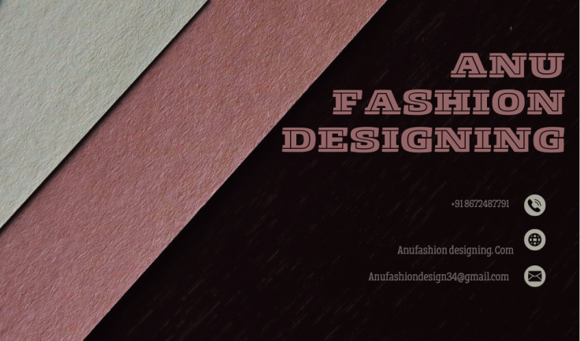

## 4 ADVANDAGES AND DISADVANDAGES

## Easy to using this canva

## Freshers can easy to design anything inthis canva

## In this canva has many templates

## Canva was very useful to everyone

# 5. CONCLUSION

## I easily finish my project business card . canva is the most useful and best app for the freshers . Beacause , that has has many templates that was easy to use